Choose a concept feature from this week's readings and submit a code snippet that shows its usage and purpose. Comment on at least two of your classmates' posts and suggest alternative implementation or usage. Explain why your suggestion has merit.

Below is a simple example of a view extension using a HTML helper method. This can also be used for Ajax and URL helper methods as well by replacing Html with the correct context which is being used. This Razor helper method can be reused in different ways. Helper methods can be as diverse and helpful as needed. In general for Razor helpers the return is typically an IHtmlString due to Razor always encoding the statement, and is a single output.

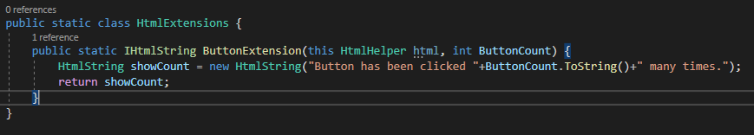



Galloway, J., Wilson, B., Allen, K. S., & Matson, D. (2014). Extending MVC, Writing HTML Helpers. In *Professional ASP.NET MVC 5* (pp. 444-445). Indianapolis, IN: John Wiley & Sons.